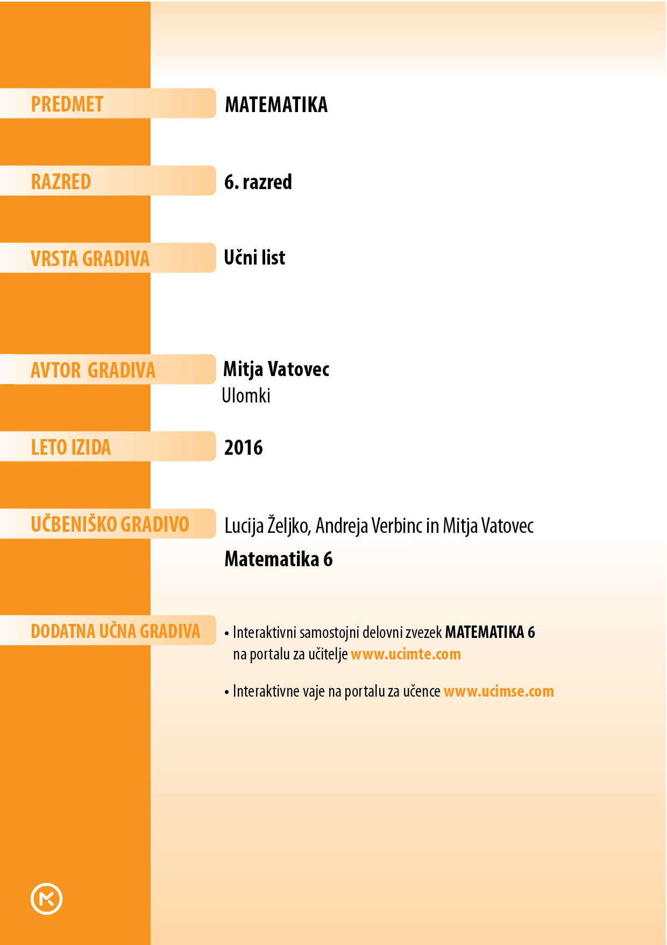



1. Pri vsakem primeru nariši daljico, ki je dolga 6 cm.
2. Daljico razdeli na 3 enake dele. Z rdečo barvo prevleci  dolžine daljice.
3. Daljico razdeli na 6 enakih delov. Z modro barvo prevleci  dolžine daljice.
4. Daljico razdeli na 12 enakih delov. S črno barvo prevleci  dolžine daljice. Kaj opaziš?
5. S kockami so prikazane vsote ali razlike ulomkov. Rezultate zapiši z ulomkom. Celoto predstavlja kocka z 8 čepki.

|  |  |
| --- | --- |
|  |  |
|  |  |
|  | č) |
|  |  |

1. Nariši daljico |*AB*| = 9 cm. Na njej označi točko *C* tako, da bo |*AC*| enaka tretjini |*AB*|. Kolikšna je dolžina daljice *CB*?
2. Nariši dva kvadrata s stranicami z dolžino 4 cm. En kvadrat predstavlja celoto. Pobarvaj  kvadratov.
3. Kvadrata razdeli na četrtine. Koliko četrtin je pobarvanih?
4. Koliko osmin bi bilo pobarvanih, če bi kvadrata razdelil na osmine? Kaj pa šestnajstin?
5. Nariši pravokotnik s stranicama dolgima 3 cm in 2 cm. Z različnimi barvami pobarvaj ,  in  pravokotnika. Kolikšen del ostane nepobarvan? Izrazi v štiriindvajsetinah.
6. Izračunaj celote.

|  |  |  |
| --- | --- | --- |
| 1. od  = 5 dℓ | 1. od  = 20 min | 1. od  = 75 cm |
| č)  od  = 70 dag | 1. od  = 34 g |  |

1. Vsakega od ulomkom  in  prikaži v kvadratu s stranico, ki meri 5 cm.
2. Zapiši z desetiškimi ulomki, kolikšen del metra je:

|  |  |  |  |  |  |
| --- | --- | --- | --- | --- | --- |
| 1. 3 dm, | 1. 4 cm, | 1. 8 mm, | č) 17 dm, | 1. 487 cm, | 1. 512 mm. |

1. S katerim številskim izrazom izračunamo število vseh žog, če vemo, da je dvanajst žog enako  vseh žog? Izpiši črko pred pravilnim izrazom.

|  |  |  |  |
| --- | --- | --- | --- |
| 1. 12 : 3 | 1. (12 : 3) ∙ 5 | 1. 12 : 5 | Č (12 : 5) ∙ 3 |



1. Vse tri daljice imajo pobarvan enak del.

|  |  |
| --- | --- |
|  |  |
|  | č) |

1. 6 cm
2. Pobarvanih je .
3. Če bi kvadrat razdelili na osmine, bi bilo pobarvanih . Če bi kvadrat razdelili na šestnajstine, bi bilo pobarvanih .
4. 

|  |  |  |  |  |  |
| --- | --- | --- | --- | --- | --- |
|  |  |  |  |  |  |
|  |  |  |  |  |  |
|  |  |  |  |  |  |
|  |  |  |  |  |  |

|  |  |  |
| --- | --- | --- |
| 1. 10 dℓ = 1 ℓ | 1. 60 min = 1 h | 1. 100 cm = 1 m |
| č) 100 dag = 1 kg | 1. 1000 g = 1 kg |  |

|  |  |  |  |  |  |  |  |  |  |  |  |  |  |  |  |  |  |  |  |  |  |  |  |  |  |  |  |  |  |  |  |  |  |  |  |  |  |  |  |  |  |  |  |  |  |  |  |  |  |  |  |  |  |  |  |  |  |  |  |  |  |  |  |  |  |  |  |  |  |  |  |  |  |  |  |  |  |  |  |  |  |  |  |  |  |  |  |  |  |  |  |  |  |  |  |  |  |  |  |  |  |  |  |  |  |  |  |  |  |  |  |
| --- | --- | --- | --- | --- | --- | --- | --- | --- | --- | --- | --- | --- | --- | --- | --- | --- | --- | --- | --- | --- | --- | --- | --- | --- | --- | --- | --- | --- | --- | --- | --- | --- | --- | --- | --- | --- | --- | --- | --- | --- | --- | --- | --- | --- | --- | --- | --- | --- | --- | --- | --- | --- | --- | --- | --- | --- | --- | --- | --- | --- | --- | --- | --- | --- | --- | --- | --- | --- | --- | --- | --- | --- | --- | --- | --- | --- | --- | --- | --- | --- | --- | --- | --- | --- | --- | --- | --- | --- | --- | --- | --- | --- | --- | --- | --- | --- | --- | --- | --- | --- | --- | --- | --- | --- | --- | --- | --- | --- | --- | --- | --- |
| |  |  |  |  |  |  |  |  |  |  | | --- | --- | --- | --- | --- | --- | --- | --- | --- | --- | |  |  |  |  |  |  |  |  |  |  | | |  |  |  |  |  |  |  |  |  |  | | --- | --- | --- | --- | --- | --- | --- | --- | --- | --- | |  |  |  |  |  |  |  |  |  |  | |  |  |  |  |  |  |  |  |  |  | |  |  |  |  |  |  |  |  |  |  | |  |  |  |  |  |  |  |  |  |  | |  |  |  |  |  |  |  |  |  |  | |  |  |  |  |  |  |  |  |  |  | |  |  |  |  |  |  |  |  |  |  | |  |  |  |  |  |  |  |  |  |  | |  |  |  |  |  |  |  |  |  |  | |  |  |  |  |  |  |  |  |  |  | |

|  |  |  |  |  |  |
| --- | --- | --- | --- | --- | --- |
| 1. m | 1. m | 1. m | č)  m | 1. m | 1. m |

1. B